LAB PROGRAMS

NAME: M.SAI HARSHITHA
REG.NO: 192424408
COURSE CODE: DSA0502
COURSE NAME: QUERY PROCESSING FOR DATASCIENCE

3.Write a Pandas program to display the details of jobs in descending sequence on job title.
Aim:
To write a Pandas program to display the details of jobs in descending order based on the job title.
Algorithm :
- Import the Pandas library.
- Create a DataFrame containing job details.
- Save the DataFrame as a CSV file.
- Read the CSV file.
- Display the original job data.
- Sort the job details in descending order of job_title.
- Display the sorted job details.
Code:
import pandas as pd
jobs = pd.DataFrame({
"job_id": ["J01", "J02", "J03", "J04", "J05"],
"job_title": ["Manager", "Analyst", "Clerk", "Developer", "Tester"],
"min_salary": [50000, 30000, 20000, 40000, 25000],
"max_salary": [100000, 60000, 40000, 80000, 50000]
})
jobs.to_csv("jobs.csv", index=False)
df = pd.read_csv("jobs.csv")
print("Original Job Details:")
print(df)
sorted_jobs = df.sort_values(by="job_title", ascending=False)
print("\nJob Details in Descending Order of Job Title:")
print(sorted_jobs)
Output:
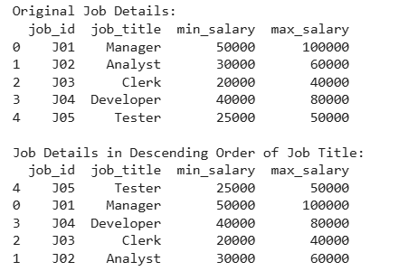

4.Write a Pandas program to create a line plot of the historical stock prices of Alphabet Inc. between two specific dates.
Aim:
To write a Pandas program to create a line plot of the historical stock prices of Alphabet Inc. between two specific dates.
Algorithm :
- Import the Pandas and Matplotlib libraries.
- Create stock price data as a DataFrame.
- Save the DataFrame as a CSV file.
- Read the CSV file.
- Convert the Date column into datetime format.
- Select the records between two specific dates.
- Create and display a line plot of the stock prices.

Code:
import pandas as pd
import matplotlib.pyplot as plt
stock = pd.DataFrame({
"Date": ["2024-01-01", "2024-01-02", "2024-01-03", "2024-01-04", "2024-01-05"],
"Close": [140, 145, 143, 148, 150]
})
stock.to_csv("alphabet_stock.csv", index=False)
df = pd.read_csv("alphabet_stock.csv")
df["Date"] = pd.to_datetime(df["Date"])
filtered_data = df[(df["Date"] >= "2024-01-02") & (df["Date"] <= "2024-01-05")]
print("Stock Prices Between Two Specific Dates:")
print(filtered_data)
plt.figure(figsize=(8,5))
plt.plot(filtered_data["Date"], filtered_data["Close"], marker='o')
plt.title("Historical Stock Prices of Alphabet Inc.")
plt.xlabel("Date")
plt.ylabel("Closing Price")
plt.grid(True)
plt.show()

Output:

